1. Go to SE80
2. Create Function Group. Refer to doc Function Group – Steps.doc.
3. Right click on function group. Create Function Module. Give appropriate name to function module. Type the following contents in source code.

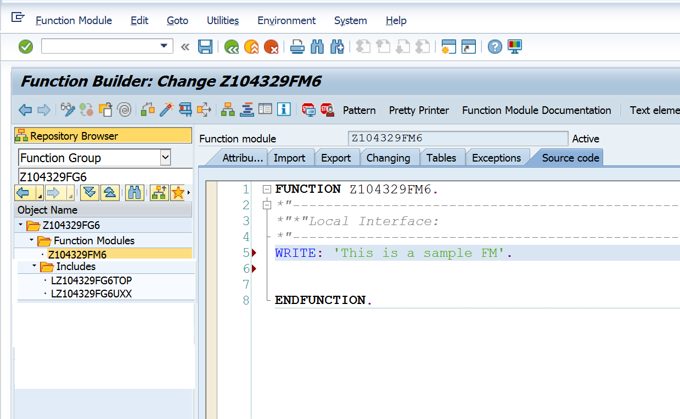

1. Execute the function module.
2. Call function module from SE38 program.

REPORT z NO STANDARD PAGE HEADING.  
  
CALL FUNCTION 'Z104329FM6'.